Background:

   Imagine the early days in New Mexico territory, a time when the land was “open range.”  There were no fences, no barbed wire, no visible boundaries to distinguish ownership of a parcel of land or to keep livestock close to home.

     It soon became evident to ranchers, farmers and cowboys that keeping track of livestock would require some way of distinguishing one rancher’s livestock from another.

     Even though branding livestock using a super-heated, iron design is most commonly associated with the cowboys of the old west, the practice actually dates back to the ancient Egyptians.

Learning Objectives:

Students will:

* understand the purpose and necessity for livestock branding in the past and today
* learn how to read and speak the language of a cattle brand
* learn the history and process of cattle branding
* understand the parallel between the pride that a cowboy felt in “riding for the brand” and how companies use advertising branding today to create that sense of loyalty and identity for a team, organization, service or product.

Essential Question: Why did cowboys and ranchers brand their livestock and how are brands read?

Overview:

In this lesson, students will learn how cowboys, ranch owners and farmers have used distinctive brands to identify cattle from Egyptian times until today.  In preparation for designing their own brand, students will learn the “language of brands” and how to decode and speak the name of a particular brand.  Students will also learn how the battle for control of New Mexico Territory led to the Lincoln County War, which made famous a number of outlaws and cattle rustlers, such as Billy the Kid.  The lawlessness and violence in Lincoln County and other parts of New Mexico territory are significant to the westward expansion story, since concerns about gaining control over the “wild west” delayed the process of New Mexico moving from territory status to statehood.

Image of branding irons by branderos.com.

Irons in the Fire

Lincoln Historic Site

Tiffanie Owen, Instructional Coordinator





Background cont:

     There were three main purposes for branding animals:

* to help identify and separate cows at rail yards or stock yards when they were being taken to market
* to identify the animal’s owner if she got lost or stolen Students will:
* to discourage cattle rustlers, or cattle thieves, from stealing them

     Brands became almost like a coat of arms or heraldic crest.  The brands not only identified the owner of a ranch, but provided a unique sense of identity and a set of traditions for the cowboys who represented the ranch.  In fact, it was not unusual for a cowboy to claim that he “rode for the brand” more than for the actual ranch owner.  Louis L’Amour described the term “riding for the brand” as a compliment of highest order and an expression of loyalty to an employer.  Today, companies still work hard to create internal branding that will inspire their employees’ sense of loyalty, identity and keep them “riding for the brand.”

Bibliography:

“What's in a Brand? The History of Cattle Branding.” *AGAmerica*, AGAmerica Lending, 28 June 2017, agamerica.com/brand-history-of-cattle-branding/.

“A Brief History of Branding.” *Convoy,*8, Jan 2014, weareconvoy.com/2014/01/a-brief-history-of-branding/.

Additional Resources:

“Decoding the Range: The Secret Language of Cattle Branding.” *Smithsonian Magazine,*Smithsonian Institution, 30 April, 2013, <https://www.smithsonianmag.com/arts-culture/decoding-the-range-the-secret-language-of-cattle-branding-45246620/>.

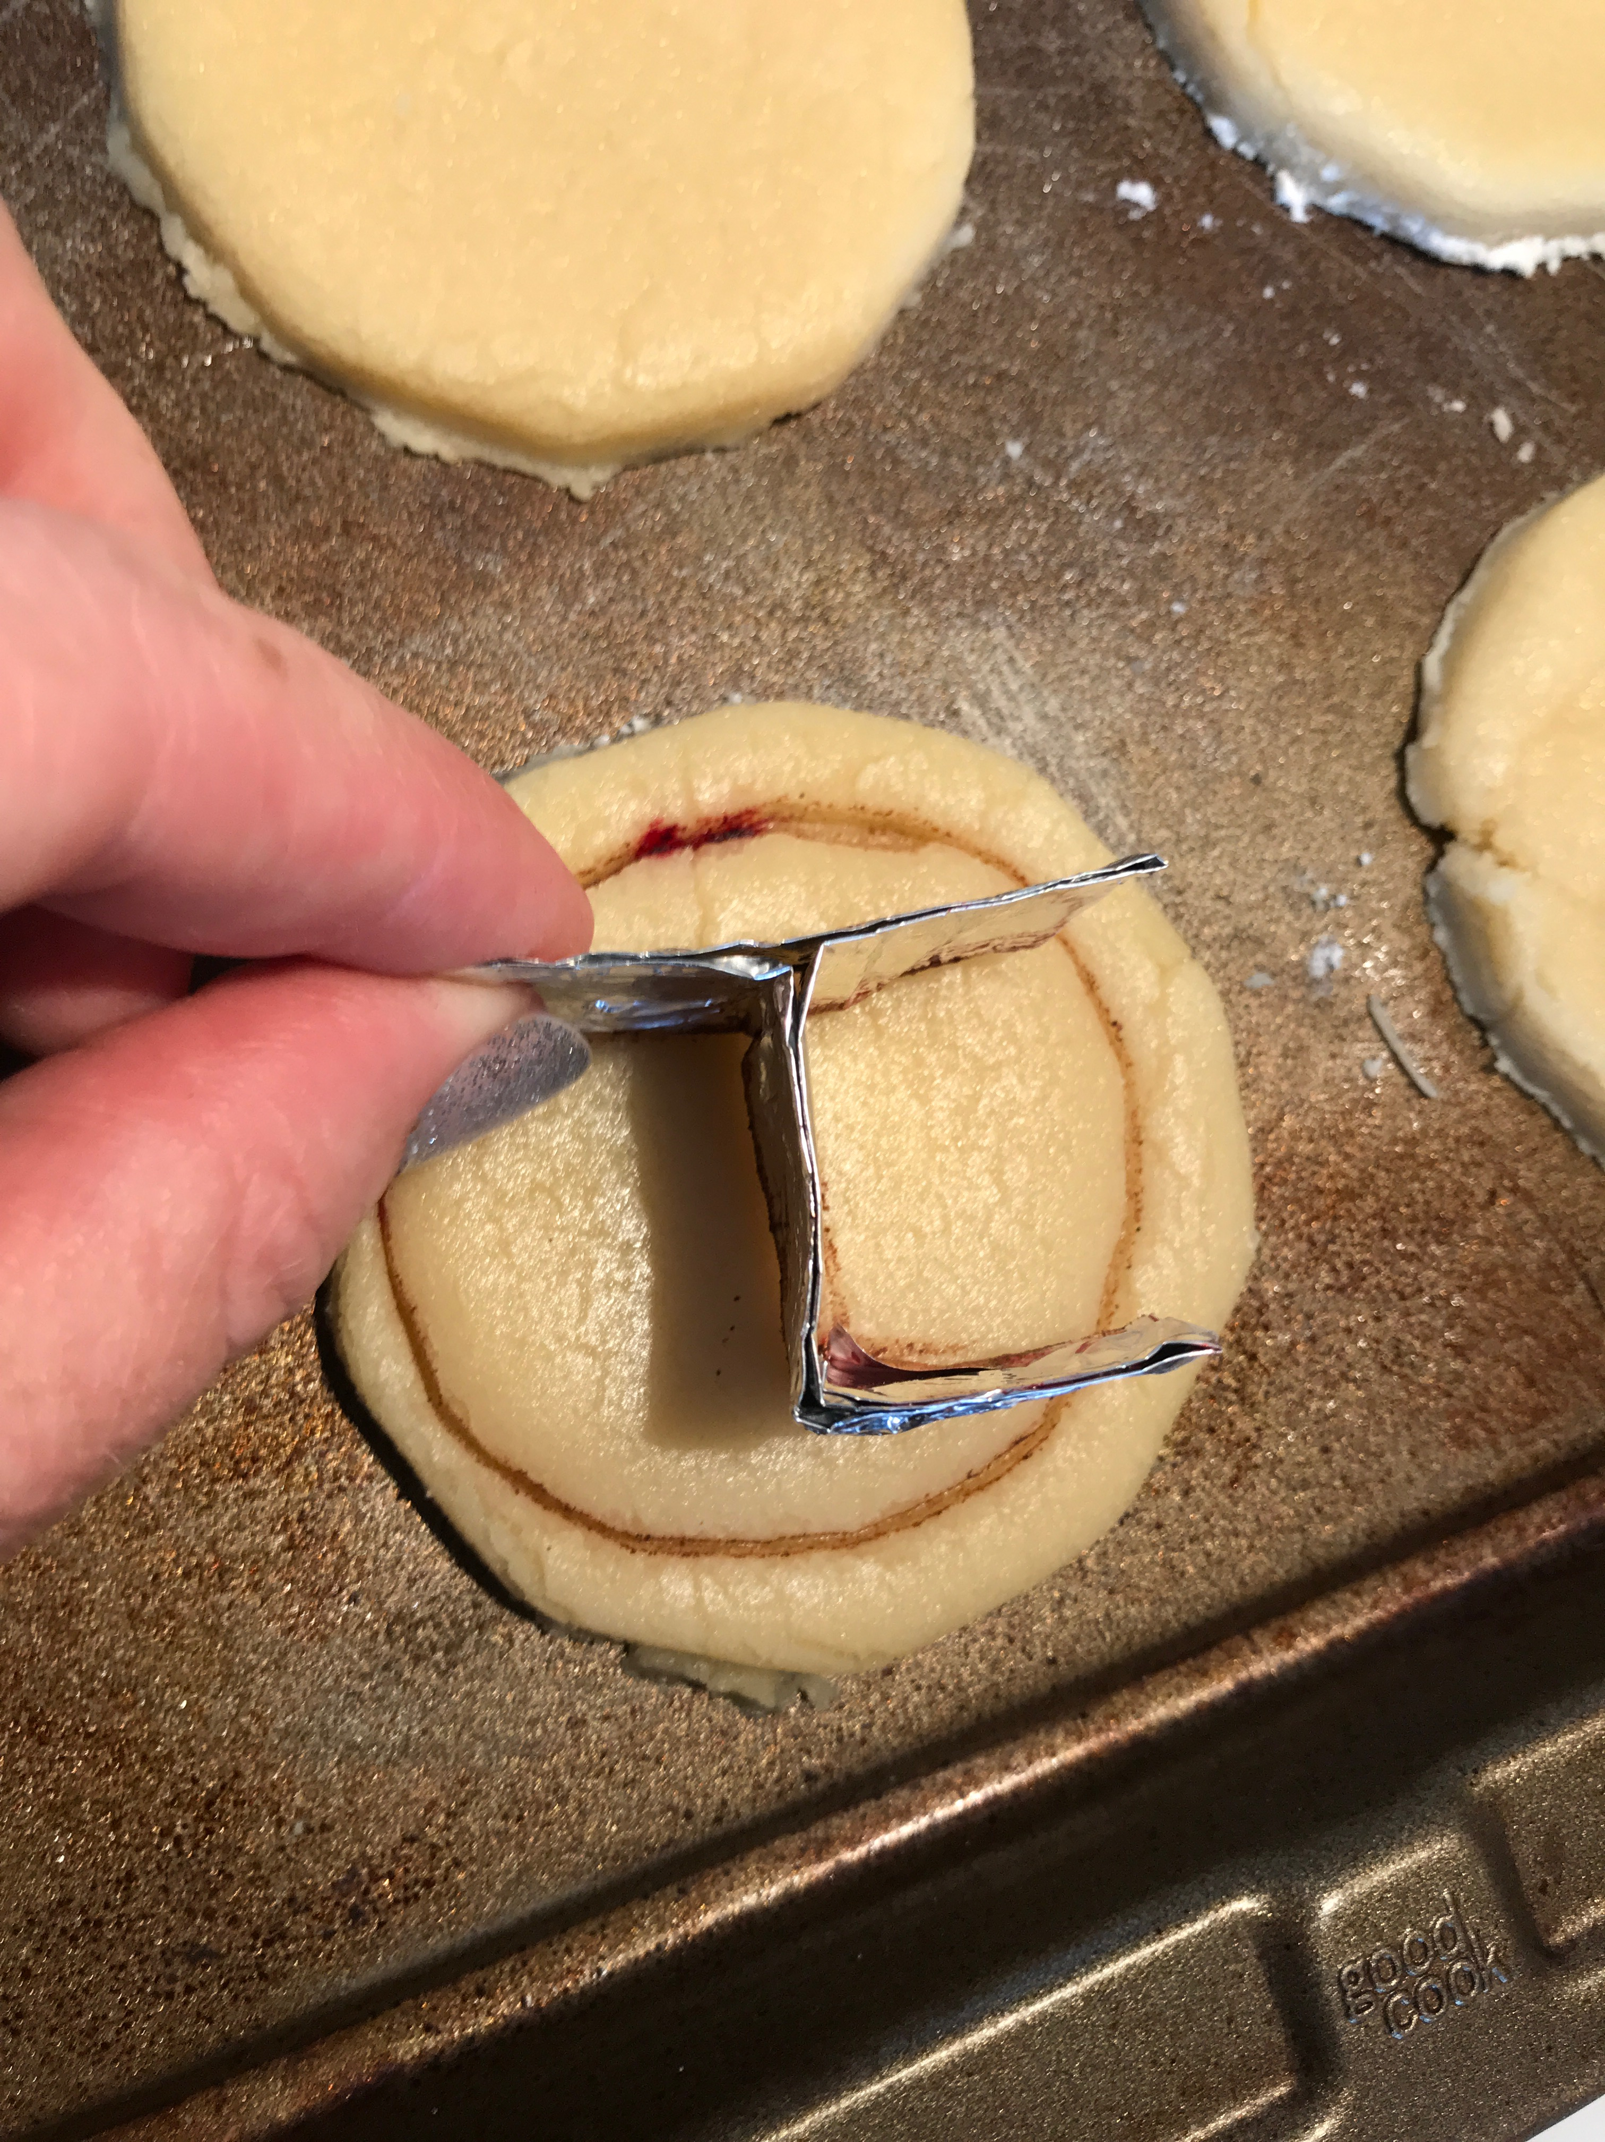

Activity Introduction/Instructions:

**Brand Your Cookies!**

Students will design and shape their own personal brand out of heavy-duty aluminum foil.  Then they will make sugar cookies and use their aluminum foil brand to stamp their cookies.

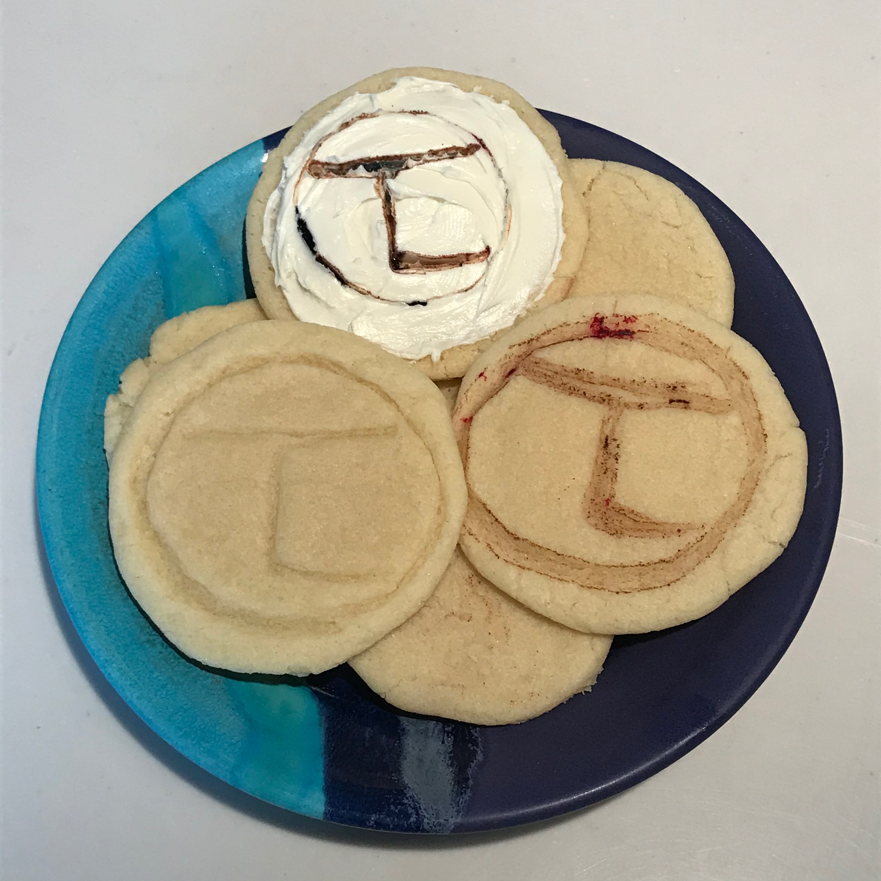

1. cut a piece of heavy-duty aluminum foil approx.. 12” x 6”
2. fold the long end over about ½”

3. continue to fold the foil over and over in ½” sections until you have a long, ½” strip

4. shape the strip of foil into a letter or shape to create your brand

5. you may have to make several strips of foil to create the entire brand

6. make your cookies according to the recipe & use cookie cutter to shape cookies

***There are several ways that you can brand your cookies. You can press the brand into the cookie dough before cooking. You can also dip the brand into food coloring or cinnamon and press into uncooked dough. You can also frost the cookies, dip the brand in food coloring and cinnamon and brand the cookie after frosting.

**Equipment Needed:** **Supplies Needed:**

**To make your cookie brand:**

scissorsheavy-duty aluminum foil

tape

**To make your cookies:**

mixing bowl sugar cookie ingredients

large spoon (or cookie mix or refrigerated cookie roll)

measuring spoons optional: frosting

spatula food coloring

rolling pin cinnamon

cookie sheet

cookie cutter or drinking glass

optional: saucer

butter knife