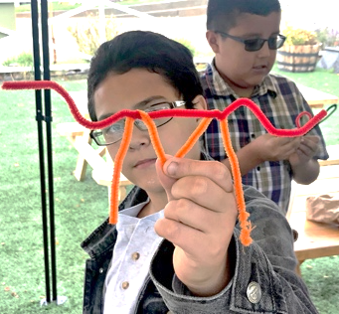
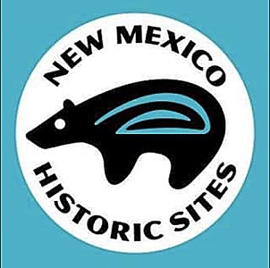
Iron Man Cookies!Iron
This activity is designed to accompany the Virtual Summer Camp lesson, Irons in the Fire, which can be found under the education tab at our website: www.newmexicohistoricsites.org
or on our New Mexico Historic Sites YouTube channel.

Anticipatory Set:
- Who do you think of when I say the words, “Iron Man?”
- Based on the video about brands and how a brand was applied to a ranch animal, what do you think might have been the job of an “Iron Man” on a ranch?
(Answer: On a ranch, the Iron Man was the cowboy who used the metal branding iron to press the hot brand to the animal’s hide.)

SWBATD synthesis of knowledge gained on the language of branding by creating their own personal brand.

Discussion:
The Branding Process
- Explain to students that on the great plains of the west, ranchers began claiming large plots of land that had water and tall grass to feed cattle. The competition between cattle ranchers to control and protect their land was fierce.
- Cows were often moved from place to place to give the land time to recover and grow new grass. Once the cows were fattened up and ready to go to market to be sold, they were driven to the next destination overland by cowboys, and sometimes taken through rail yards and stockyards. Along the trip, it was not unusual for cows to get lost or to get mixed up with cows from other ranches.
- To identify their cows, ranchers would brand their calves with a distinctive marking, (similar to a modern-day tatoo), by pressing a heated metal symbol or design into the hide of the animal. The branding iron would burn through the hair and other layer of skin on the calf, creating a permanent identifying mark that would last throughout the cow’s lifetime. A brand never disappears and can even be seen after the animal is butchered.
- The branding process was a difficult, dirty and tiring process for the cowboys and it took a team to get the job done. First, the “ketch hand” would rope the calf and pull it up to the fire for branding.
- Then a cowboy called the “flanker” would grab the calf by the ear and loose end of the flank, lift it up and lay it on its side. Another cowboy would call out the brand of the calf’s mother and someone would bring the correct brand to the fire.
- Finally, while one man held the calf, an “iron man” would press the fire-hot, metal brand against the calf’s hide on its shoulder, hip or rib, leaving a permanent scar.
Learning Activity:
Materials Needed~
- 2 pipe cleaners per student
- scissors

Design Your Own Brand
For this activity, students will get to apply what they’ve learned about brand design and the language of brands by designing their own personal brand. They may choose to use their initials, a number (such as their own number on a sports team or the number of a professional athlete whom they admire), and symbols (such as arrows going in any direction, straight bars, squiggly lines, hearts or diamonds).
Instruct students that they may use their two pipe cleaners and scissors to shape their personal brand. They can cut their pipe cleaners into smaller pieces if necessary, but they should be careful to make sure they don’t cut pieces too short.
Remind students that a brand should be simple enough to be shaped with metal and it must be easy to read. Also, a simpler brand is less painful for the livestock.

Closure:
From the video, we learned about branding techniques that date back to the time of the ancient Egyptians. Can you think of any modern technology that ranchers might be able to use to keep track of their livestock? How about technology that your parents use in the car or that you use on your phone to determine where you are on a map? (Answer: GPS)
Also, DNA testing can be used to tell if an animal is a genetic match to others from a particular ranch or farm. Although both of these techniques give ranchers and farmers additional tools to use against loss and theft (YES! Cattle rustling still happens today!), the technique that most livestock owners still prefer is good old fashioned branding.
- Depending on the complexity of your brand, you may only stamp once, or you may have separate letters or symbols that will be stamped individually to create your completed brand. For instance, my brand includes my three initials, “T”, “L” and “O”. First, I shaped one strip of foil into a circle to make my “O”. After I stamped the “O” into my cookies, I stamped the “T-L” ligature into the center of the “O”.

Brand Your Cookies!

ketch hand – in livestock branding, the ketch hand is the cowboy who would lasso a calf and bring it to the fire for branding

flanker – the flanker is the cowboy who would grab the calf by the ear and the loose end of the flank to lay the calf on its side for branding

iron man – the iron man is the cowboy who would actually press the heated branding iron to the hide of the calf or cow

maverick – Samuel A. Maverick was a Texas engineer, politician and rancher who refused to brand his cattle. His name became the term used to describe an unbranded or orphaned range colt or cow that had escaped from the herd. His name has also become the official term used to describe individuals who refuse to follow the rules of social order.
Iron Man Vocabulary

