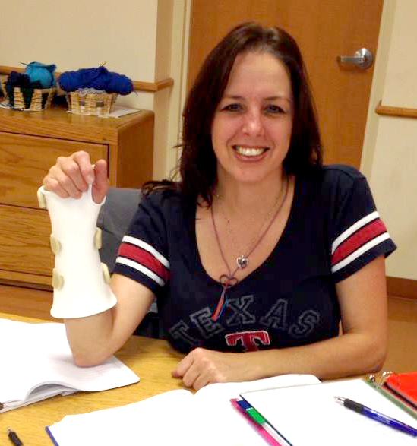
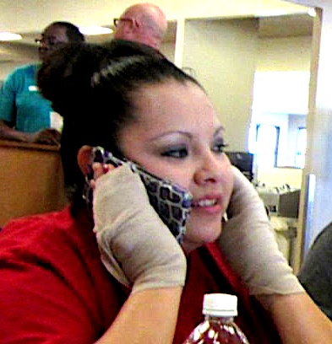

My Disability Day (Activity 9-12)

Throughout history, soldiers have returned from war with physical disabilities, traumatic brain injuries, and psychological trauma. Non-military people sometimes suffer the same impairments after developing a disease, being in an accident, or experiencing something extremely emotional such as the death of a family member.
One of the best ways to develop empathy is to experience some of the challenges that they deal with every day.

Step 1: Choose your disability.
Think about something that you might have in your home or a family member’s home that can help you recreate a disability. (Remember to check with family members first and ask for permission to borrow or use equipment or supplies.)
- visual impairment – sunglasses with Vaseline rubbed on the lenses
- deafness – sound cancelling headphones or ear plugs
- arm amputation – use something soft such as a belt from a bathrobe to tie your arm to your torso below the elbow or pull one arm inside shirt sleeve
- leg amputation – use crutches, wheelchair or walker and keep one leg up
- injured rotator cuff (shoulder) – use an arm sling and remember that you cannot lift or move your arm without extreme pain
- leg, ankle, or foot injury – wheelchair or immovable leg brace
- burned hands – wrap in elastic bandage wrap from wrist to fingertips or cover hands with
tight-fitting socks
- wrist injury – splint or carpal tunnel braces (apply splint to dominant hand if possible)
Step 2: Experience
CAUTION: Do not put yourself into any situations that could cause you to get hurt, such as trying to cross the street blind or going downhill in a wheelchair. If you choose visual impairment, ask a sibling or friend to assist you in unfamiliar places or if you have stairs at home.
You will be writing about your disability experience during two parts of a day. One will be during a single class period. The other will be at home as you go through your normal ADLs (activities of daily living). As part of your experience, try to include dressing or undressing and at least one meal.
Step 3: Write About Your Disability Day
- Introductory Paragraph – Introduce yourself and describe your disability. Explain why you chose your disability. Do you know someone who lives with this challenge? How does it make you feel to see their struggles?
- 3 (or more) Body Paragraphs – What did you find most difficult as you went through your day? Did others treat you differently? If someone offered help, did you accept or were you offended? What could you no longer do that you missed most? Did you find ways to adapt that allowed you to accomplish tasks in a different way?
- Conclusion Paragraph – Has your Disability Day changed the way you view people with disabilities? If so, how? Do you have a new appreciation for your life and abilities after this experience?

